**Manual Tests:**

**Simple View:**

Confirm the following:

* There are no duplicates of a specific combination of a meeting ID and person name.
* In the First Name and Last Name column, the listed names are words and not numbers.

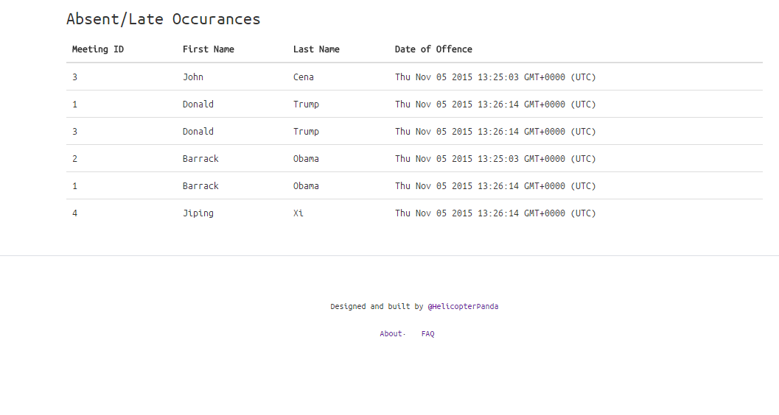

**Android Testing:**

Confirm the following through the IDE:

* Scanning the image located at “src\test\testcode.jpg” will print the following into the log.

Barcode = employee_id=5

first_name=Kelsey

last_name=Yuen

* The information is only printed once into the log and then the program exits.
* Scanning the code causes the entry at “mighty-sands-7891.herokuapp.com/” with the following information (Meeting ID = 4, First Name = Kelsey, Last Name = Yuen) to disappear.
* Confirm that you can enter an existing Meeting ID and it will delete that entry for that user.
* Confirm that setting Meeting ID to a nonexistent number does not crash the program.